|  |  |
| --- | --- |
|  | **AIR UNIVERSITY** |
| **DEPARTMENT OF COMPUTER SCIENCE** |
| **Lab Task 3** |

**Student Name: Hamza Umer Farooq Reg. No: 200789**

**Subject: Compiler Construction Semester: VIII**

**Objective: Tokenization**

**ASSESSMENT:**

|  |  |  |  |  |  |
| --- | --- | --- | --- | --- | --- |
| **Attributes** | **Excellent**  **(5)** | **Good**  **(4)** | **Average**  **(3)** | **Satisfactory**  **(2)** | **Unsatisfactory (1)** |
| **Ability to Conduct**  Task |  |  |  |  |  |
| **Ability to assimilate the results** |  |  |  |  |  |
| **Effective use of theorems/postulates/formulas** |  |  |  |  |  |

Total Marks:

Obtained Marks:

**REPORT ASSESSMENT:**

|  |  |  |  |  |  |
| --- | --- | --- | --- | --- | --- |
| **Attributes** | **Excellent**  **(5)** | **Good**  **(4)** | **Average**  **(3)** | **Satisfactory**  **(2)** | **Unsatisfactory**  **(1)** |
| **Data presentation** |  |  |  |  |  |
| **Experimental results** |  |  |  |  |  |
| **Conclusion** |  |  |  |  |  |

**Code to check:**

if (a >= 10)

{ Sum = x;

print (“value is x”);

}

else{

return 30;

}

**Macros:**

%{

#include <stdio.h>

%}

%option noyywrap

DIGIT [0-9]

LETTER [a-zA-Z]

WHITESPACE [ \t\n]+

%%

{DIGIT}+ {printf("Integer: %s\n", yytext);}

{LETTER}+ {printf("Identifier: %s\n", yytext);}

{WHITESPACE} {}

. {printf("Unknown Token: %s\n",yytext);}

%%

int main() {

//

}

**Lexemes/Tokens according to rules/macros defined above:**

<Identifier: if>  
<Unknown Token: (>  
<Identifier: a>  
<Unknown Token: >>  
<Unknown Token: =>  
<Integer: 10>  
<Unknown Token: )>  
<Unknown Token: {>  
<Identifier: Sum>  
<Unknown Token: =>  
<Identifier: x>  
<Unknown Token: ;>  
<Unknown Token: }>  
<Identifier: else>  
<Unknown Token: {>  
<Identifier: return>  
<Integer: 30>  
<Unknown Token: ;>  
<Unknown Token: }>

**QUESTION 2A**

**IF ELSE**

%{

#include <stdio.h>

%}

%option noyywrap

DIGIT [0-9]

IF_ELSE if|else

FLOAT (0|[1-9][0-9]*)\.[0-9]+

INT {DIGIT}+

HEADER_INIT #include

HEADER_FILE <[a-zA-Z0-9_]+\.h>

%%

{HEADER_INIT} { printf("Header Init: %s\n",yytext);}

{HEADER_FILE} { printf("Header File: %s\n", yytext); }

{IF_ELSE} { printf("IF/ELSE: %s\n",yytext);}

{INT} { printf("Integer: %s\n", yytext); }

{FLOAT} { printf("Float: %s\n", yytext); }

[a-zA-Z][a-zA-Z0-9]* { printf("Identifier: %s\n", yytext); }

[(){}] {printf("Delimeter: %s\n",yytext);}

[;] {printf("Semicolon/Line End: %s\n",yytext);}

[:] {printf("Colon: %s\n",yytext);}

[,] {printf("Comma: %s\n",yytext);}

"[" {printf("Square Bracket: %s\n",yytext);}

"]" {printf("Square Bracket: %s\n",yytext);}

[+\-*/] { printf("Arith Operator: %s\n", yytext); }

[=+><] { printf("Operator: %s\n",yytext);}

[\".*\"] {printf("Literal: %s\n",yytext);}

[\t\n] {}

" " {}

. { printf("Unknown Token: %s\n",yytext);}

%%

int main() {

    FILE* fp;

    char filename[30];

    printf("\nEnter File name: ");

    scanf("%s",filename);

    fp = fopen(filename,"r");

    yyin = fp;

    yylex();

}

**OUTPUT:**  
  
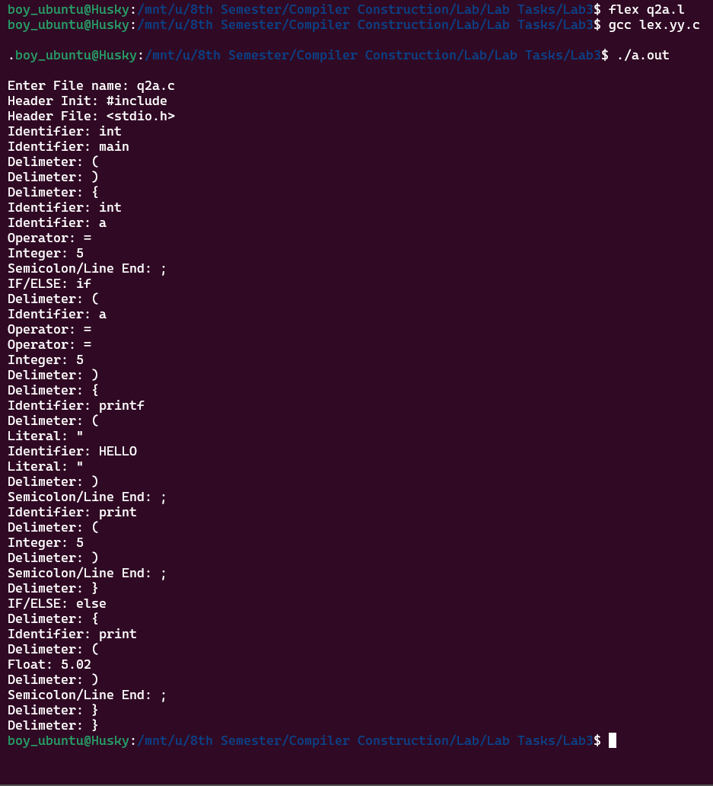

**QUESTION 2B**

**SWITCH-CASE**

%{

#include <stdio.h>

%}

%option noyywrap

DIGIT [0-9]

FLOAT (0|[1-9][0-9]*)\.[0-9]+

INT {DIGIT}+

HEADER_INIT #include

HEADER_FILE <[a-zA-Z0-9_]+\.h>

SWITCH_CASE "switch"|"case"|"default"

%%

{HEADER_INIT} { printf("Header Init: %s\n",yytext);}

{HEADER_FILE} { printf("Header File: %s\n", yytext); }

{SWITCH_CASE} { printf("Switch/Case: %s\n",yytext);}

{INT} { printf("Integer: %s\n", yytext); }

{FLOAT} { printf("Float: %s\n", yytext); }

[a-zA-Z][a-zA-Z0-9]* { printf("Identifier: %s\n", yytext); }

[(){}] {printf("Delimeter: %s\n",yytext);}

[;] {printf("Semicolon/Line End: %s\n",yytext);}

[:] {printf("Colon: %s\n",yytext);}

[,] {printf("Comma: %s\n",yytext);}

"[" {printf("Square Bracket: %s\n",yytext);}

"]" {printf("Square Bracket: %s\n",yytext);}

[+\-*/] { printf("Arith Operator: %s\n", yytext); }

[=+><] { printf("Operator: %s\n",yytext);}

[\".*\"] {printf("Literal: %s\n",yytext);}

[\t\n] {}

" " {}

. { printf("Unknown Token: %s\n",yytext);}

%%

int main() {

    FILE* fp;

    char filename[30];

    printf("\nEnter File name: ");

    scanf("%s",filename);

    fp = fopen(filename,"r");

    yyin = fp;

    yylex();

}

**OUTPUT**

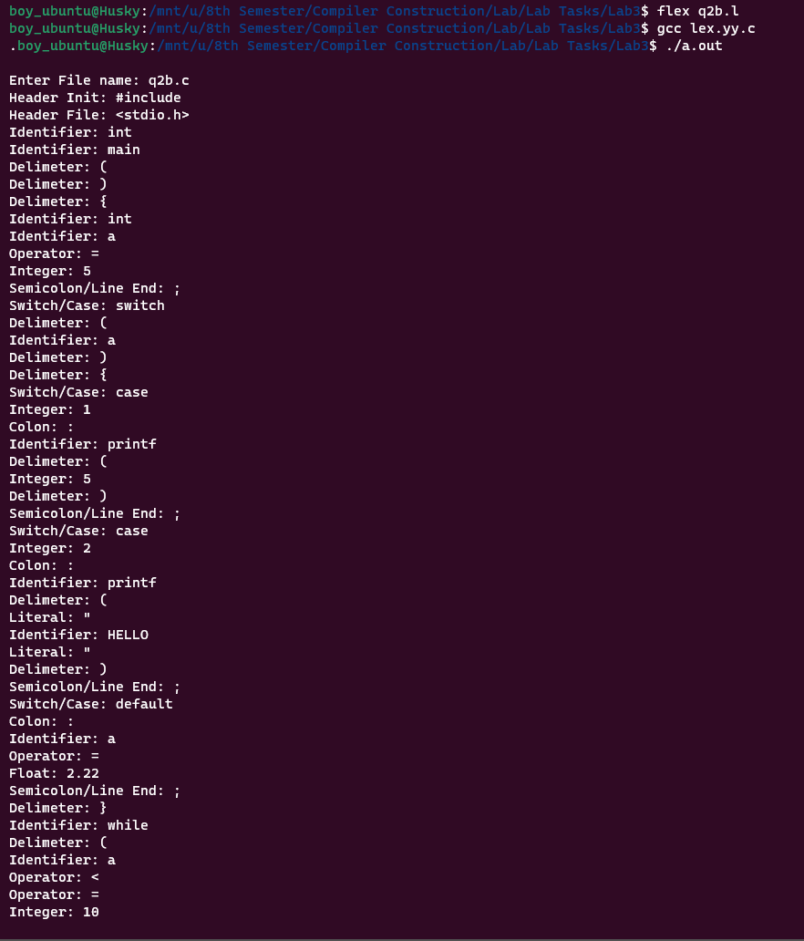

**Sample codes used for testing q2a.l and q2b.l**

**q2a.c**

#include <stdio.h>

int main(){

int a = 5;

if (a == 5){

printf("HELLO");

print (5);

}

else {

print(5.02);

}

}

**q2b.c**

#include <stdio.h>

int main(){

int a = 5;

switch(a){

case 1:

    printf(5);

case 2:

    printf("HELLO");

default: a = 2.22;

}

while (a<=10){

a=a+1;

}

}